Infotainment Control Mirror - CGEA1.3

Functional Description

The purpose of the Infotainment control mirror is to show the status of various Infotainment characteristics when the Infotainment characteristic changes. The display will indicate the vehicle’s current Infotainment characteristic status.

This Infotainment Control Mirror function will use the EOL Configuration input, the cluster Operational_Mode and the requirements in the IPC Infotainment SPSS to determine the Infotainment Control Mirror display.

Interfaces

Interface Context Diagram (I/O Block Diagram)
Figure 1 Infotainment Control Mirror Interface Context Diagram
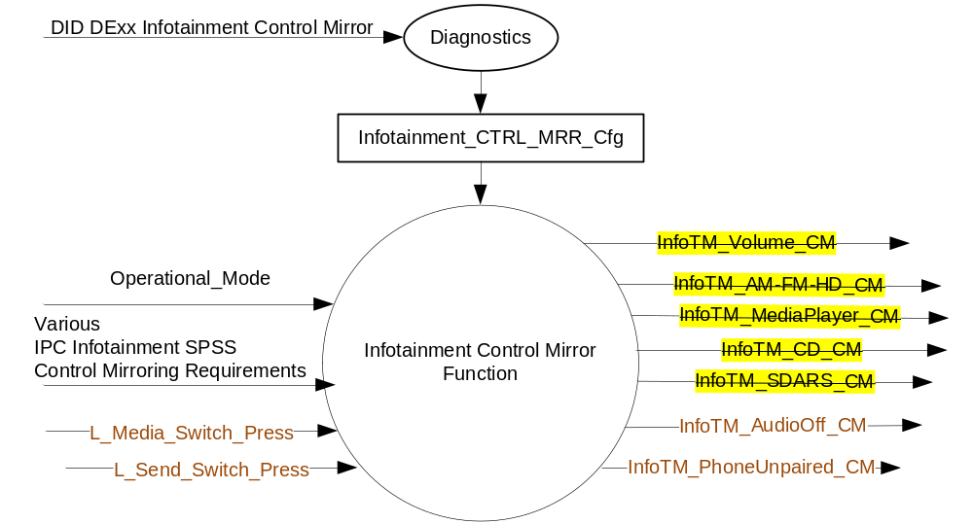

Inputs

      - INTERNAL:
- Operational_Mode
- Infotainment_CTRL_MRR_Cfg
- L_Media_Switch_Press (Refer Steering Wheel Switch – 4-Way with Rocker Hotkeys – CGEA 1.3 STSS)
- L_Send_Switch_Press (Refer Steering Wheel Switch – 4-Way with Rocker Hotkeys – CGEA 1.3 STSS)

Outputs
- InfoTM_Volume_CM
- InfoTM_AM-FM-HD_CM
- InfoTM_MediaPlayer_CM
- InfoTM_CD_CM
- InfoTM_SDARS_CM
- InfoTM_AudioOff_CM
- InfoTM_PhoneUnpaired_CM

Function/Performance

Operational Modes

Mode | Differentiating Vehicle Conditions
Sleep Mode | Infotainment Mode Control Mirror OFF
Limited Mode | Infotainment Mode Control Mirror OFF
Normal Mode | Infotainment Mode Control Mirror ON/OFF
Crank Mode | Infotainment Mode Control Mirror ON/OFF

Voltage Levels

Refer to the Features table located in Operational Modes and Voltage Range Strategies STSS.

Human-Machine Interface

Visual

Indicator Graphics / Display Format
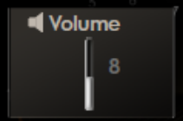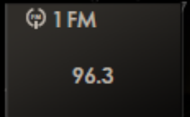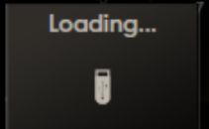
InfoTM_Volume_CM = 0x1 InfoTM_AM-FM-HD_CM = 0x1 InfoTM_MediaPlayer_CM = 0x1

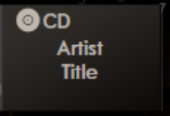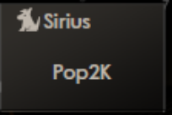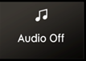
InfoTM_CD_CM = 0x1 InfoTM_SDARS_CM = 0x1 InfoTM_AudioOff_CM = 0x1

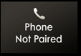
InfoTM_PhoneUnpaired_CM = 0x1

Above are example graphics.
Actual graphics are to be provided by Ford HMI or Studio and approved by the DI Application for each program.

Audio

None.

System Accuracy

The state matrixes in 1.3.5.1 shall be executed within 100msec of a state change as specified in the IPC Infotainment SPSS Control Mirroring Requirements.

Operation: Performance and Functional

Subsystem Algorithm Flowchart / State Diagram

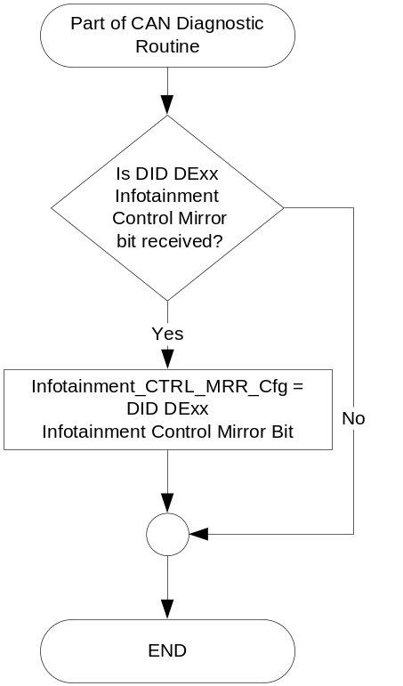

- State Matrix for InfoTM_Volume_CM
Operational_Mode | Infotainment_CTRL_MRR_Cfg | IPC Infotainment SPSS  Control Mirroring Requirement | InfoTM_Volume_CM
Normal or  Crank | Enabled | AMFM Client shall display  Volume information | 0x1 (Active)
All Other Cases |  |  | 0x0 (No Display)

- State Matrix for InfoTM_AM-FM-HD_CM
Operational_Mode | Infotainment_CTRL_MRR_Cfg | IPC Infotainment SPSS  Control Mirroring Requirement | InfoTM_AM-FM-HD_CM
Normal or  Crank | Enabled | AMFM Client shall display AM/FM/HD information | 0x1 (Active)
All Other Cases |  |  | 0x0 (No Display)

- State Matrix for InfoTM_MediaPlayer_CM
Operational_Mode | Infotainment_CTRL_MRR_Cfg | IPC Infotainment SPSS  Control Mirroring Requirement | InfoTM_MediaPlayer_CM
Normal or  Crank | Enabled | Media Player Client shall display the media player information | 0x1 (Active)
All Other Cases |  |  | 0x0 (No Display)

- State Matrix for InfoTM_CD_CM
Operational_Mode | Infotainment_CTRL_MRR_Cfg | IPC Infotainment SPSS  Control Mirroring Requirement | InfoTM_CD_CM
Normal or  Crank | Enabled | CD Client shall display the  CD information | 0x1 (Active)
All Other Cases |  |  | 0x0 (No Display)

- State Matrix for InfoTM_SDARS_CM
Operational_Mode | Infotainment_CTRL_MRR_Cfg | IPC Infotainment SPSS  Control Mirroring Requirement | InfoTM_SDARS_CM
Normal or  Crank | Enabled | SDARS Client shall display  SDARS information | 0x1 (Active)
All Other Cases |  |  | 0x0 (No Display)

- State Matrix for InfoTM_AudioOff_CM
Operational_Mode | Infotainment_CTRL_MRR_Cfg | L_Media_Switch_Press | IPC Infotainment SPSS Control  Mirroring Requirement | InfoTM_AudioOff_CM
Normal or | Enabled | TRUE | Media Player Client shall display  the media player information | 0x1 (Active)
Crank
All Other Cases |  |  |  | 0x0 (No Display)

- State Matrix for InfoTM_PhoneUnpaired_CM
Operational_Mode | Infotainment_CTRL_MRR_Cfg | L_Send_Switch_Press | IPC Infotainment SPSS Control  Mirroring Requirement | InfoTM_PhoneUnpaired_CM
Normal or | Enabled | TRUE | Phone Connected Status information from Infotainment SPSS | 0x1 (Active)
Crank
All Other Cases |  |  |  | 0x0 (No Display)

Operation Description (supports algorithm flowchart /state diagram)

The HMI logic specified in the cluster display logic STSS shall define when to trigger the Dimming Interior Illumination control popups, which should be based upon a request to be displayed.

The logic specified in the Control Mirror Arbitrator STSS shall define the timeout of the popup and any arbitration for requesting the display of the popup, which should be based upon a change in the value of InfoTM_XXX_CM variables.

The cluster display logic STSS shall specify the display arbitration when an AHUD is present in the vehicle.

The program specific graphics corresponding to the value of InfoTM_XXX_CM and its location in the cluster shall be provided by Ford HMI or Studio and approved by the DI Application for each program.

The InfoTM_AudioOff_CM wil be active only if L_Media_Switch_Press is TRUE and the infotainment audio stack is empty. Refer IPC Infotainment SPSS and “ Message Center – M3 Display with Message Center and Quick Action Menu Button Interface – CGEA1.3” STSS for additional details.The state can be determined based on Infotainment signals as follows:
ACU_RUResReqstStatus_St = 0x1 (Deallocated)
ACU_RUReqstrSystem_St = 0x0 (FrontRequester)
ACU_RUAudioSource_St = 0xC (NotReq)
ACU_RUReqstrPriority_St = 0xE (NotReq)

The InfoTM_PhoneUnpaired_CM will be active only if L_Send_Switch_Press is TRUE and the Bluetooth Phone pairing is off. Refer IPC Infotainment SPSS and “ Message Center – M3 Display with Message Center and Quick Action Menu Button Interface – CGEA1.3” STSS for additional details.The state can be determined based on Infotainment signals as follows:
VRM_BTPhoneSts_St = 0x7 (NoLnkToBt)

Function Safety Classification (EMC)

B

Memory Storage

Parameter Name | Description | Value at  Battery Connect | Value at  Module Wake-up
Infotainment_CTRL_MRR_Cfg | EOL Configuration to enable Infotainment Control Mirror display in the IPC. | Use stored value | Use stored value
InfoTM_Volume_CM | Indicates the state of the Infotainment Volume Control Mirror display | 0x0 (No Display) | 0x0 (No Display)
InfoTM_AM-FM-HD_CM | Indicates the state of the Infotainment AM/FM/HD Control Mirror display | 0x0 (No Display) | 0x0 (No Display)
InfoTM_MediaPlayer_CM | Indicates the state of the Infotainment Media Player Control Mirror display | 0x0 (No Display) | 0x0 (No Display)
InfoTM_CD_CM | Indicates the state of the Infotainment CD Control Mirror display | 0x0 (No Display) | 0x0 (No Display)
InfoTM_SDARS_CM | Indicates the state of the Infotainment SDARS Control Mirror display | 0x0 (No Display) | 0x0 (No Display)
InfoTM_AudioOff_CM | Indicates the state of the Infotainment Audio Off Control Mirror display | 0x0 (No Display) | 0x0 (No Display)
InfoTM_PhoneUnpaired_CM | Indicates the state of the Infotainment Phone paired status - Control Mirror display | 0x0 (No Display) | 0x0 (No Display)
Operational_Mode | 4 state indicator for HUD operational mode | Limited | Limited, Normal or Crank
Various IPC Infotainment SPSS Control Mirroring Requirements | Requirements specified in the IPC Infotainment SPSS that pertain to Control Mirroring | See IPC Infotainment SPSS | See IPC Infotainment SPSS

Error Handling

Missing Message Strategy

There are no DTCs associated with this feature since all of the inputs are internal to the IPC.

Diagnostics

Self Test

None

Engineering Test Mode

Reference section “Dealer / Engineering Test Mode (ETM)”

Part II Performance

Supported Diagnostic Trouble Codes (DTCs)

No DTCs shall be logged for this feature.

DID DExx
Bits | State: Description | "0" | "1" | Default | Comments/  Information
1 | Infotainment Control Mirror | Disabled | Enabled | Enabled | Use on vehicles with Quick Action Menus, parameter allows the “Audio Off” and the “Phone Not Paired” pop up control mirrors.
*Byte and bit location to be identified in Part II Specification for this cluster

Reference Specification

- Control Mirror Arbitrator – CGEA1.3
- IPC Infotainment SPSS
- Appropriate Message Center Display STSS
- Appropriate Program Specific Text Translation File
- Appropriate Program Specific IPC Menu Structure File
- Appropriate Program Specific Wallpapers

Revision History

SPSS Module Revision History

Revision Level | Name | Change Description | Date
1.0 | T. Cwik | Initial Release for review | 8/27/2014
1.1 | R. Chalanti | Additional Contor Mirrors requested by D544 program team to use the Audio and Phone Quick Action Menu buttons  If Audio is OFF, display a Audio_Off control Mirror  If Phone button is pressed, when phone is unpaired, display a Phone_Unpaired control Mirror | 5/29/2015
2.0 | S. Watkins | Per DI Change Control on 3/10/2016 Stavros Dionyssopolous requested the ability to enable just the “Audio Off” and “Phone Not Paired” control mirrors (these were added in version 1.1) and not all 7 control mirrors. Since the other 5 control mirrors are not planned to be used on D544 or U554 or any program in the immediate future, we are re-defining the existing config bit to enable ONLY the 2 desired control mirrors. In the future, if all 7 control mirrors are desired, we will update this STSS and “un-strikethrough” the other 5 control mirrors. (i.e. delete this version and revert back to version 1.1)  All changes highlighted in yellow.  - Struck out the below in this STSS:  - InfoTM_Volume_CM  - InfoTM_AM-FM-HD_CM  - InfoTM_MediaPlayer_CM  - InfoTM_CD_CM  - InfoTM_SDARS_CM | 4/7/2016

